IS EDUCATION AT THE POINT OF INFLECTION?
The 15th Annual Conference of The Boston Pledge
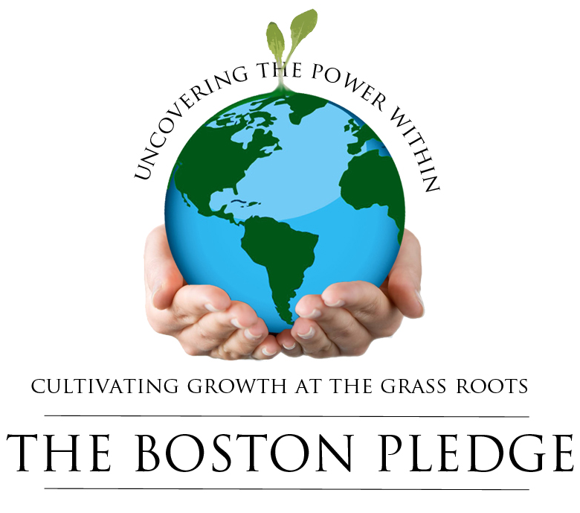

The Program: Is Education at the Point of Inflection? @ ASEAN Auditorium The Fletcher School of Law & Diplomacy, 160 Packard Av. Medford, MA

2:15 to 2:30 PM Introduction to The Boston Pledge

2:30 to 2: 45 PM Civilization in Transition: Do we need to rethink the Future of Education? Partha S Ghosh

2:45 to 3:00 PM State of Education in the US: What’s working and not working? John Hodgman Ex-President of Massachusetts Technology Development Corporation (MTDC) <

3:00 to 3:15 PM Is Technology hurting the Education Process? Dr. Jahangir Sultan
Professor of Bentley University, Director Marblehead Partners

3:15 to 4:15 PM Technology, Education and Civilization
Isa Kaftal Zimmerman, Ed. D. (IKZ Advisors, LLC, STEM Education and Leadership) with Leo Brehm, Northborough & Southborough Public Schools

4: 15 to 4: 45 PM Awakening Intelligence: Education for a Planetary Consciousness
Dr. Neela Bhattacharya Saxena Professor of English and Women's Studies will explore Indic ways of awakening our depth intelligence, as our neurotic and accumulative education system no longer serves the needs of the planet.

4:45 to 5:15 PM Raising the Bar for Action & Experiential Learning: the Rapidly Increasing Challenge of Engagement from Early Childhood Through to Higher Education and Lifelong Learning: Ronald Jonash, Chairman, Global Innovation Management Institute, Professor of Strategy and Innovation, Hult International Business School, Senior Partner at Center for Innovation, Excellence and Leadership (IXL)

In partnership with….

